**Floating Ball Simulation**

**3D Simulation Project**

**CMSC 162**

*Submitted to:*

**Prof. Sandra Mae Famador**

*Submitted by:*

**Jessah Marie Duran**

June 4, 2018

# **Table of Contents**

**Overview**……………………………………………………………………………………...........................2

Introduction…………………………………………………………………………….....................................2

Genre…………………………………………………………………………….................................................2

**Simulation** .…………………………………………………………………………………..........................3

Objects……………………………………………………………………………...............................................3

Mechanics…………………………………………………………………………….........................................3

Controls and Movements …………………………………………………………………………….............4

**Interface**……………………………………………………………………………………............................4

**Technical**………………….…………………………………………………………………………………………. 4

Flow Chart..………………………………………………………………....................................................4

Language..……………………………………………………………….......................................................5

Graphics Library..………………………………………………………………..........................................5

Classes..………………………………………………………………...........................................................5

# **Overview**

**Introduction**

Throughout the years, visualization and graphics have undoubtedly progressed exponentially for productivity and economical purposes. With the continuous growth of technology, it is of no question how these fields are already and are still in the process of changing the world and human lifestyle in general. One of the relevant product of visualization and graphics is computer simulation. Computer simulations are computer programs that can reproduce the behavior of a system using a mathematical model. These simulations have been exploited through branches of science, among these are physics, astrophysics, chemistry, medical biology, engineering, social science and many others.

This paper presents a simulation inspired PhET Interactive Simulations’ Density Simulation. PhET Interactive Simulations was founded in 2002 as a project at University of Colorado Boulder that offers free interactive math and science simulations. [1] The Floating Ball Simulation is a simpler implementation of PhET’s Density Simulation that simulates a falling ball, how it behaves once it reaches the water surface, and how the water surface level reacts once the ball is dropped.

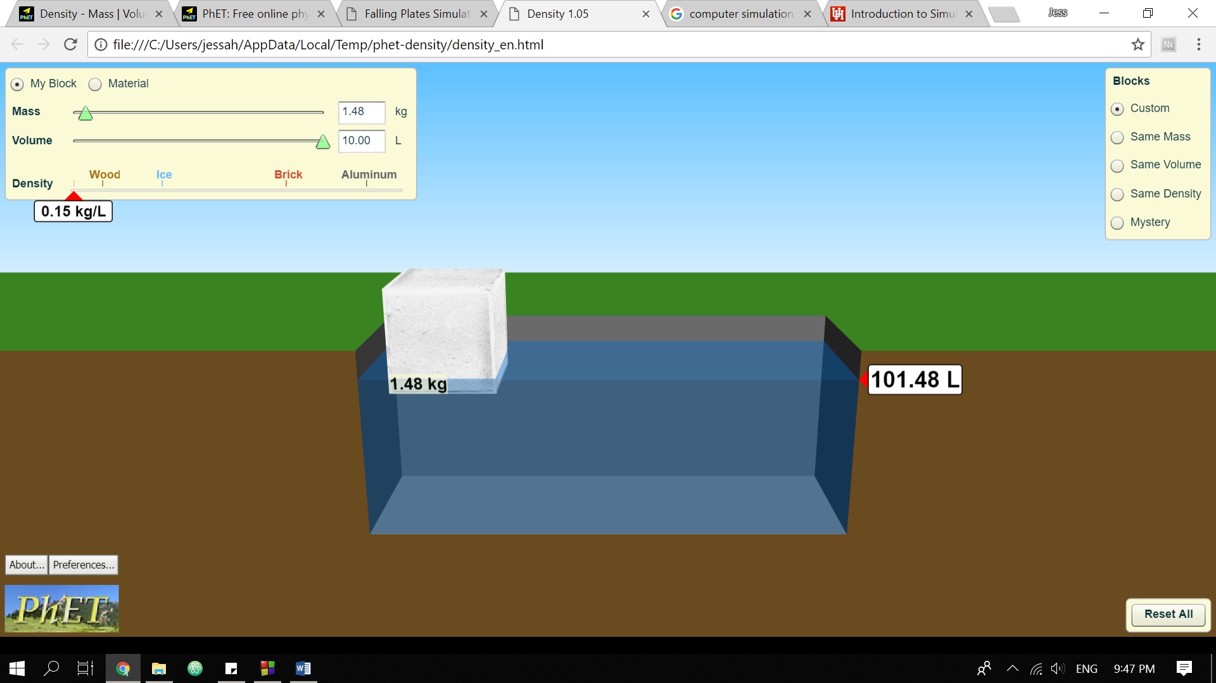

Figure . PhET's Density Simulation

**Genre**

This simulation falls along the educational category, specifically Physics for kids. This simulation could help users learn about the very basic properties of floating, density and buoyancy.

# **Simulation**

**Objects**

There are only two objects in this game: the floating ball and the aquarium. The floating ball was created using the a glut native matrix for a solid sphere (glutSolidSphere) that was subdivided around the Z axis into slices and along the Z axis into stacks. The aquarium object was rendered with the used of GL Quads matrices. The water surface inside the aquarium was rendered with a GL Quad plane with an opacity set into semi-transparent to model how water looks like in real life.

|  |  |
| --- | --- |
| Figure 2. Floating Ball | Figure 3. Aquarium |

**Mechanics**

The simulation starts up with the floating ball held constant in the air. Once triggered, the ball slowly starts to free fall with gravity and bounces when it reaches the aquarium’s water level surface. Once the ball hit the water surface, the water level also displaces. Additional options also include changing the floating ball’s volume depending on the users’ like.

**Controls and Movements**

The main controls for this simulation include the spacebar, +, - and the s key. The spacebar releases the ball in mid-air thus invokes it to start freefalling. The + and - keys increases and decreases the ball’s volume respectively. The s key refreshes the simulation and resets all the values to default.

**Interfaces**

# 

Figure . Simulation Interfaces

# **Technical**

**Flow Chart**

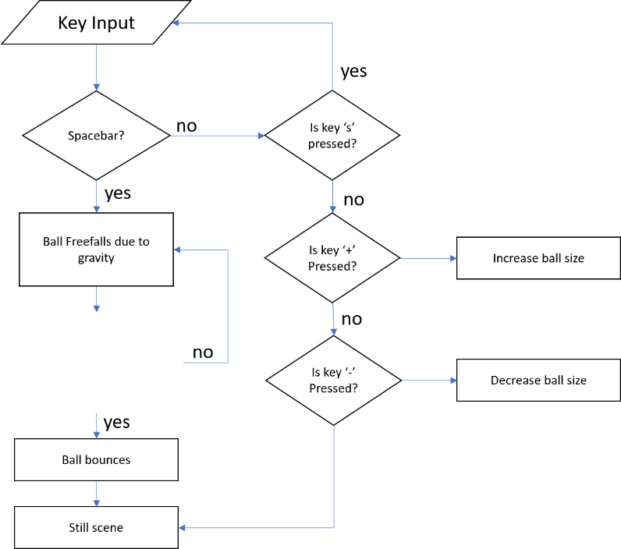

Figure 5. Flow Chart

**Language**

Floating ball simulation was programmed using C++ and Code::Blocks IDE.

**Graphics Library**

Floating ball simulation uses freeglut and opengl libraries for the graphics rendering.

# **Classes**

* **Text** – this static class renders different kinds of text styles: H1, H2 and P, H for headers and P for paragraphs.
* **Ball** – a render of a solid sphere that is subdivided around the Z axis into slices and along the Z axis into stacks.
* **Quads** – A native GL vector used to render 4 planes that serves as the surface of the aquarium and water.

1. PhET Interactive Simulations – https://phet.colorado.edu/